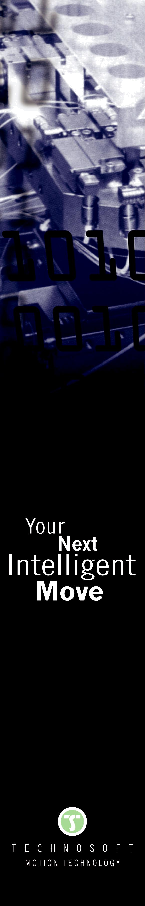
iPOS4808 VX – Compact High Power Density Servo Drive

Designed for compatibility with all motor technologies

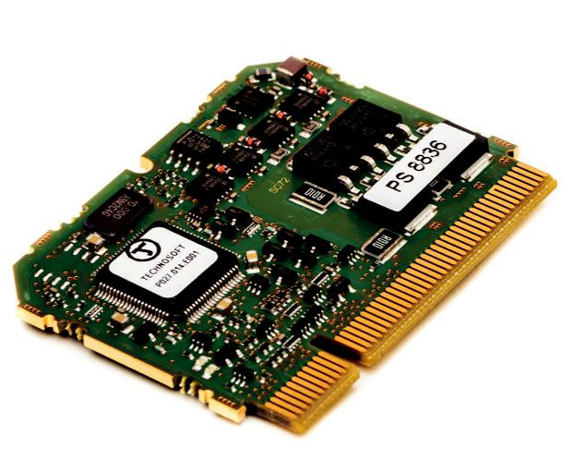
The iPOS4808 VX intelligent servo drive is a plug-in card from Technosoft’s iPOS line of drives that can control any DC brush, rotary / linear brushless, or step motor up to 400 W. Executing locally programmed functions or instructions received from various communication networks, the drive interfaces with typical feedback devices like incremental and sin/cos encoders, digital or linear Halls.
Rated for 8A continuous (at 48 V) and 20 A peak current, the iPOS4808 offers high power-density on a very compact board – only 44 x 56 mm of PCB space.

Communication channels include RS-232 serial communication, EtherCAT via an extension module, or directly CANopen.

Modularly designed to cover from low- to high-volume applications, iPOS4808 VX integrates all the basic motor control functions and the motion control features on a single plug-in module.

Specifically developed to be PCB embedded, the iPOS4808 VX comes with standard PCIe mating connectors and can be mounted vertically on a motherboard. The plug-in card format and its light weight (just 15 g) makes it ideal for assembly in critical-space applications.

This intelligent drive is capable of performing in various modes, including position control, speed control, torque, external analog, reference, etc. Two-phase or three-phase steppers are controllable in classical closed loop mode or sinusoidal FOC. The drive also features sinusoidal control of brushless motors. Several digital inputs and outputs, as well as analog inputs are available for direct integration in the user application.

For the definition and execution of motion sequences, the powerful Technosoft Motion Language (TML) instruction set is supported. The motion sequences can be stored and executed in standalone mode operation of the drive. Commissioning and programming are easy with the Technosoft EasyMotion Studio software platform.

Specifications can be found at:

https://www.technosoftmotion.com/en/intelligent-drives-and-motors/ipos-line/ipos4808/ipos4808-vx

For further information, please contact:

Valentina Dumitru

Marketing and communication

Tel.: +41 (0)32 732 55 00

E-Mail: v_dumitru@technosoftmotion.com

Technosoft S.A., Avenue des Alpes 20, CH-2000 Neuchâtel, Switzerland

Tel : +41 (0) 32 732 55 00, Fax : +41 (0) 32 732 55 04, www.technosoftmotion.com

