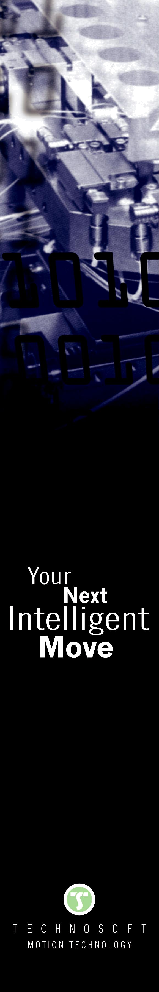
TECHNOSOFT presents the iPOS2401 MX-CAT World smallest EtherCAT drive!
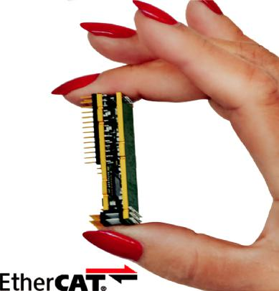

High end positioning applications where space is critical find now an optimal solution in the incredibly small iPOS2401 servo drive from Technosoft with EtherCAT interface.

Small and lite, 19 x 50 x 10mm and weighting only 12 grams, the iPOS2401 MX-CAT drive can be used in high precision positioning applications with any motor technology (brushless, stepper, DC/voice coil or linear) that require no more than 1A continuous at 24V.

Users can realize an optimal mechanical integration due to the plug-in design of the iPOS2401 that offers full flexibility in terms of motherboard design and connectors choice for either single or multi-axes applications.

- miniaturized drive yet with no compromise in performance, the iPOS2401 MX-CAT sup-ports full CoE (CAN application protocol over EtherCAT) protocol making it the ideal solu-tion for medical, robotics, instrumentation or automation projects where a high end Swiss product can make the difference in terms of quality and performance of the application.

- liter CAN version is also available embedding a motion controller that can execute complex motion sequences programmed in TML (Technosoft Motion Language), stored at drive level and called by specific CANopen commands to reduce the bus traffic in multi-axes applications.

In either EtherCAT or CANopen version, the iPOS2401 complete the extended Technosoft offer (from 25W to 1.6kW) in terms of intelligent drives with embedded motion controller for high end positioning applications.

For further information, please contact:

Valentina Dumitru

Marketing and communication

Tel.: +41 (0)32 732 55 00

E-Mail: v_dumitru@technosoftmotion.com

Technosoft S.A., Avenue des Alpes 20, CH-2000 Neuchâtel, Switzerland

Tel : +41 (0) 32 732 55 00, Fax : +41 (0) 32 732 55 04, www.technosoftmotion.com

