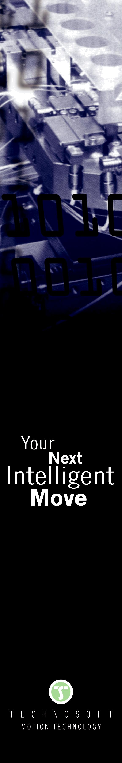
TECHNOSOFT Drives with Integrated Safety
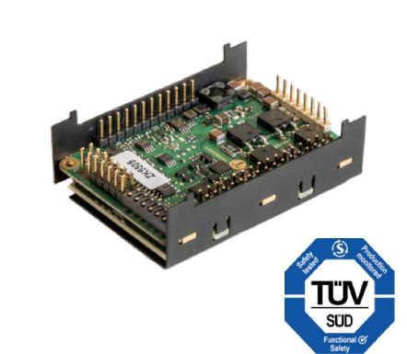

TECHNOSOFT is pleased to inform all its partners that selected products of the iPOS servo drive family now benefit from the certification for the STO (Safe Torque Off) capability.

As part of the company’s effort to continually improve our product offering while meeting market demands for integrated safety, TECHNOSOFT can now propose two versions of the iPOS4808 MY family that benefit from a high degree of performance from the STO implementation point of view : SIL3 and PLe in accordance with the EN 61800-5-2 standard.

The Safe Torque Off function safely validates the pulses controlling the power stage of the drive. When activated, the drive is reliably torque-free. This state is monitored internally in the drive.

The STO function is implemented using simple solid state hardware for high reliability reasons. Since on the classic safety circuit the redundancy is done by 2 contactors connected in series with the motor, on the integrated STO function the redundancy is done using 2 separate STO opto-isolated inputs. If both STO inputs are in “high” state, the motor is allowed to generate torque. If at least one of the 2 STO inputs are not in “high” state, the power stage will become inactive (no pulses controlling the power stage) and the motor will be free of torque.

The advantage of the integrated STO (SIL3, Cat3, PL-e) safety function compared with electromechanical safety technology based on contactors is the elimination of separate electromechanical components and the effort that would be required to wire and service them. The electrical arching is totally eliminated. The overall dimensions of the integrated STO solution are highly reduced, while the cost reduction is also very important compared to classic electromechanical technology.

With certification granted by the recognized body TÜV SUD, the iPOS4808 MY drives with STO represent the ideal solution for most applications that require 48 V and up to 8 A of continuous current, with either CAN (iPOS4808 MY-CAN-STO) or EtherCAT (iPOS4808 MY-CAT-STO) communication and for any type of brushed, brushless, linear or step motors.

This allows users to reduce the system’s cost, while increasing the safety level of their application.

For further information, please contact:

Valentina Dumitru

Marketing and communication

Tel.: +41 (0)32 732 55 00

E-Mail: v_dumitru@technosoftmotion.com

Technosoft S.A., Avenue des Alpes 20, CH-2000 Neuchâtel, Switzerland

Tel : +41 (0) 32 732 55 00, Fax : +41 (0) 32 732 55 04, www.technosoftmotion.com

